SEPTEMBER 2021 ACTIVITIES
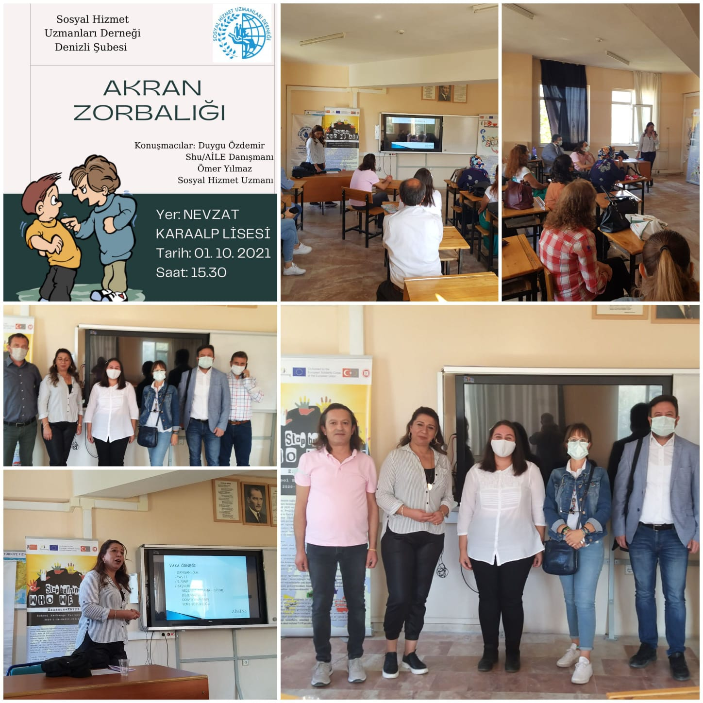
WE attended a seminar by Social Service Department of Denizli in our school. By the way we had a chance to introduce our project. We talked about the target groups and the outputs we have gained so far.

OCTOBER 2021 ACTIVITIES

1st LTT in NEVZAT KARALP ANATOLIAN HIGH SCHOOL, DENİZLİ, TURKEY

Before our guests come to our country, we prepared badgets for each of them including their personal information and some mottos and quotations about bullying and cyberbullying.
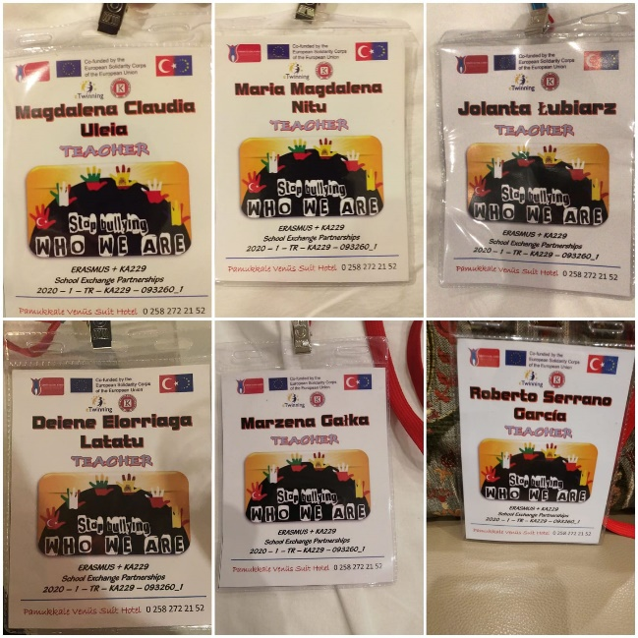
Here are our badges.

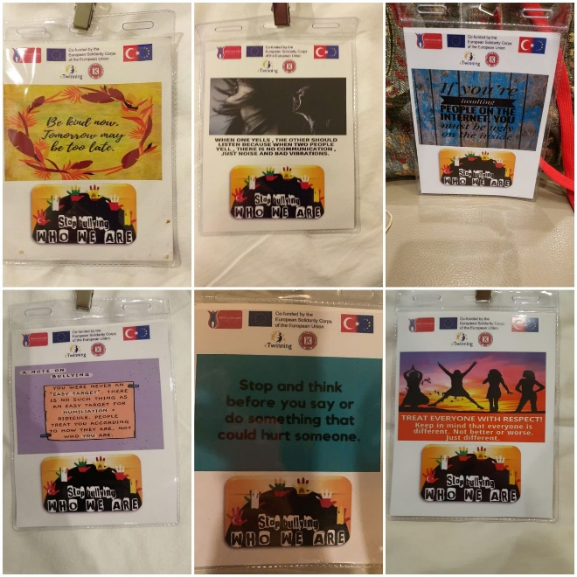

We held our first face to face meeting with the partners.
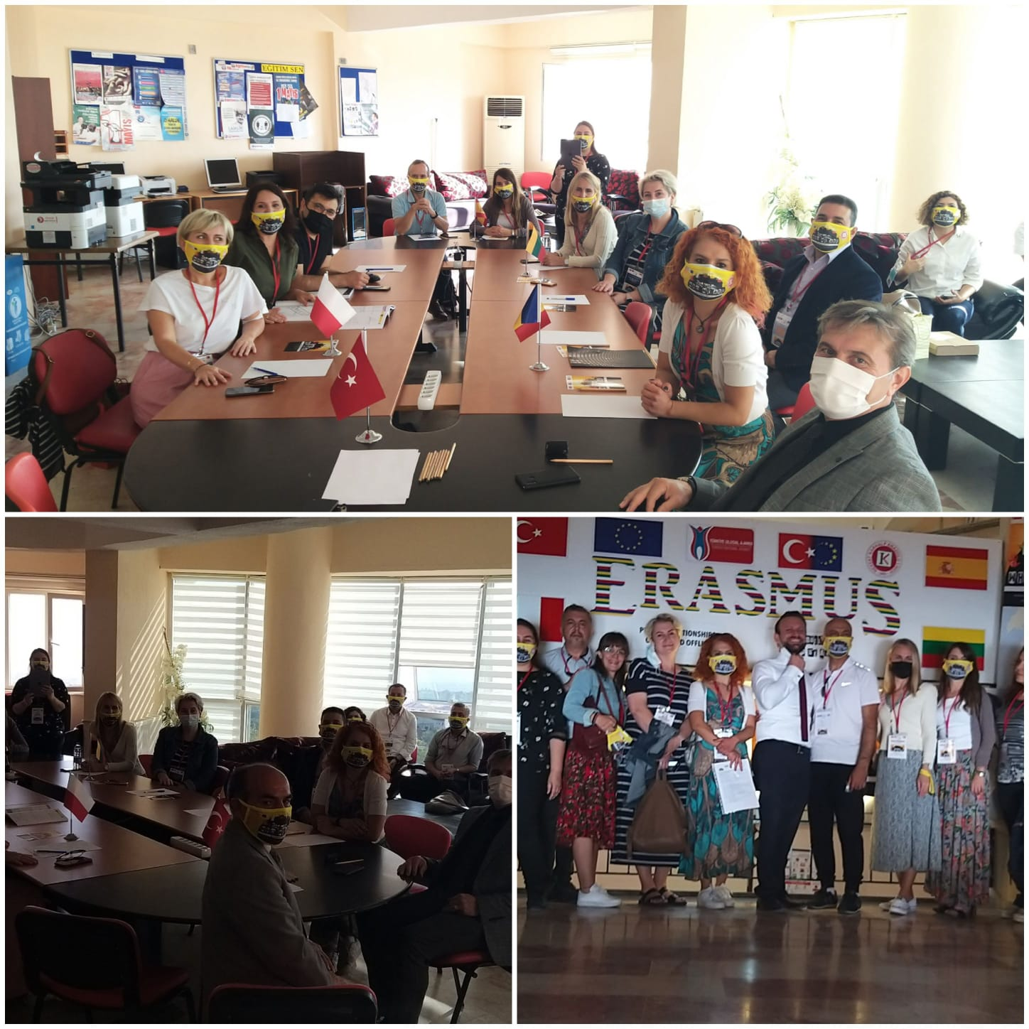

Students learnt how to play “mancala” , “ tug of war” and “marbling” which are traditional Turkish games.

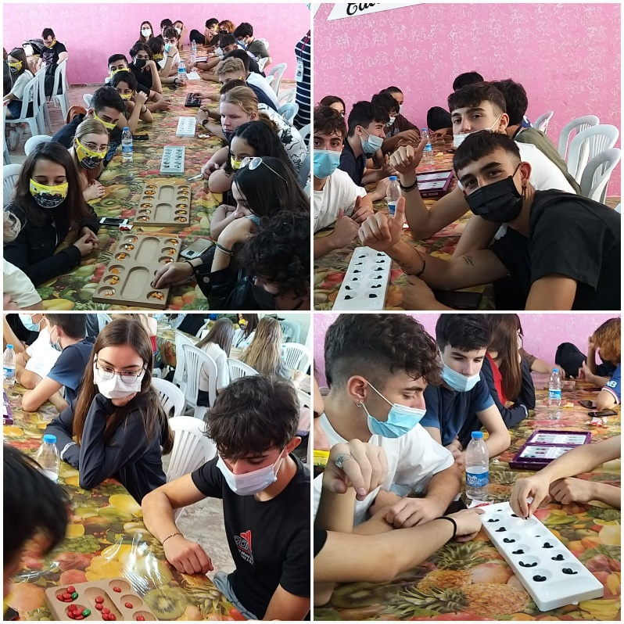

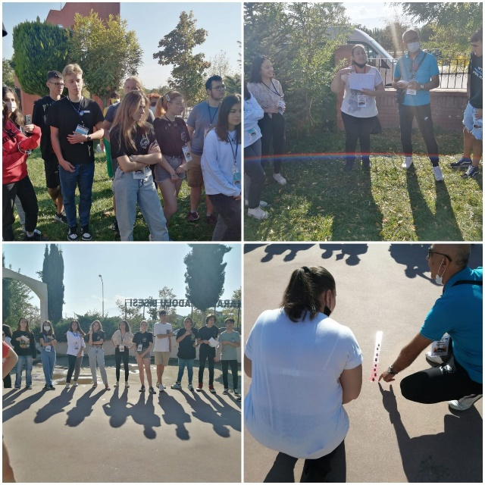

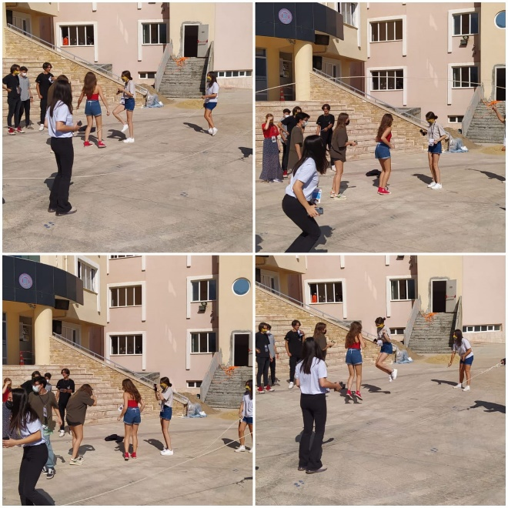
They learnt how to play “ratele şicvanatorii” which is a traditional Romanian game.
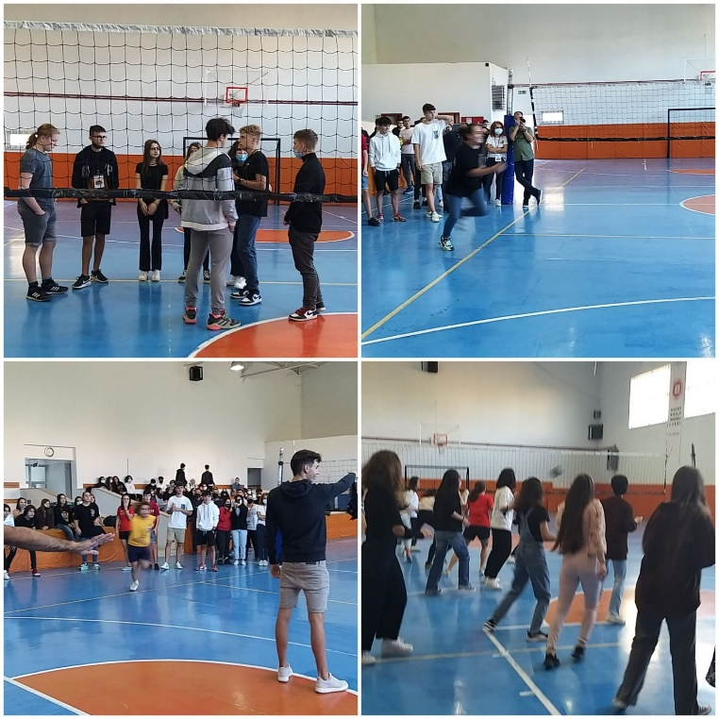

They experienced Lithuanian traditional game named Jurgeli, meistreli
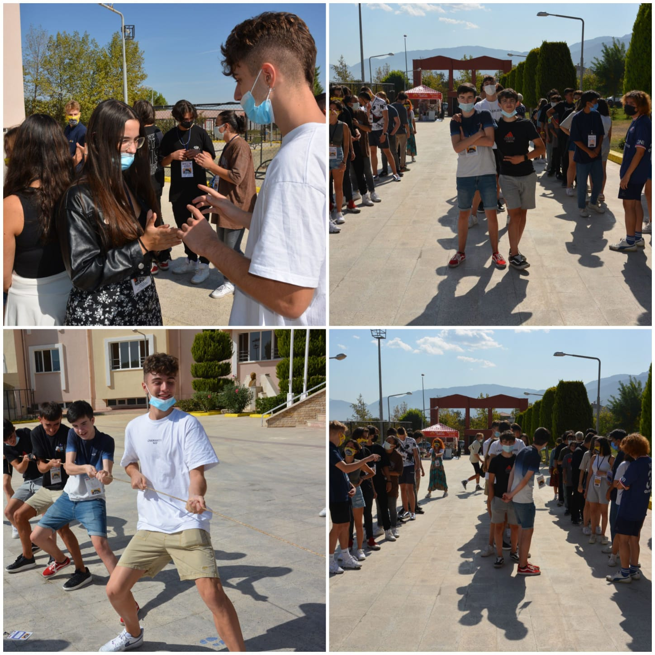
Spanish game “SOCATIRA”

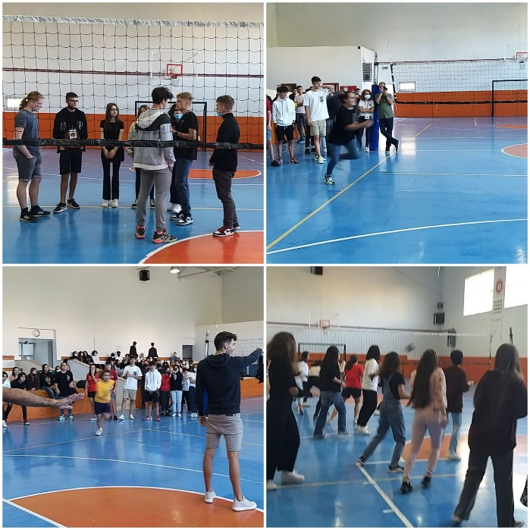

Romanian game “SOTRON”
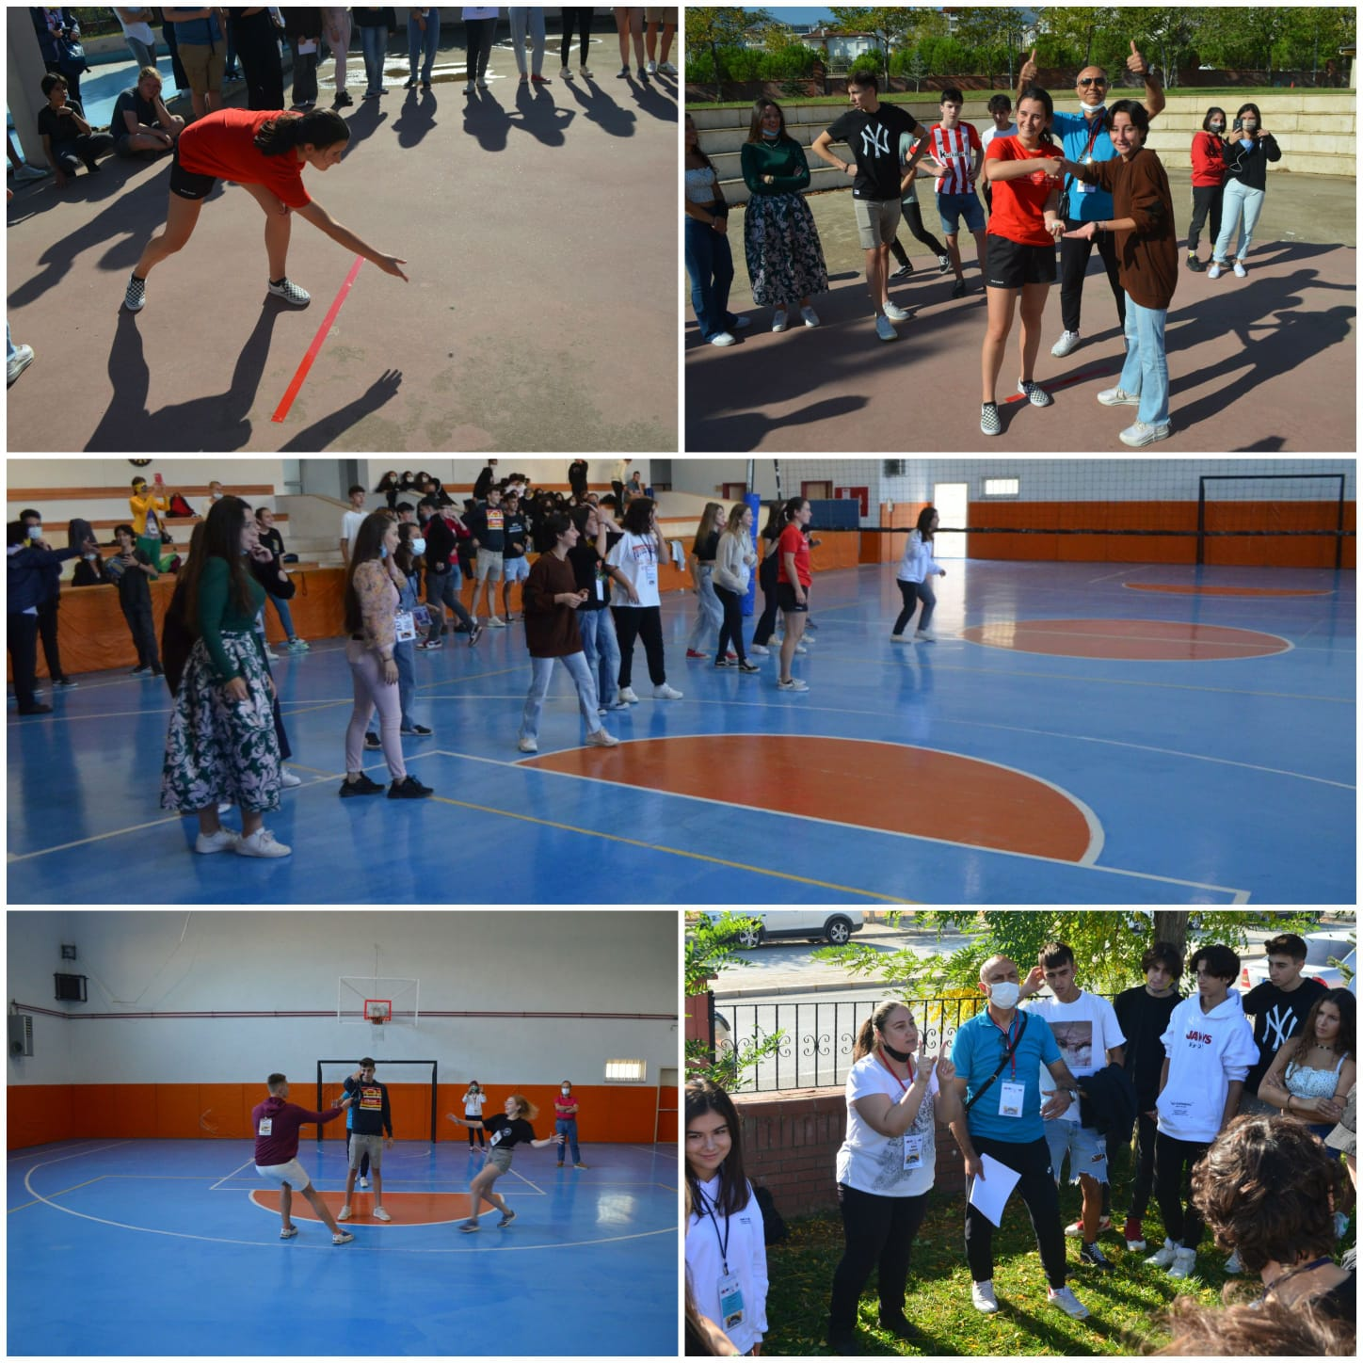

Italian game “WITCH COMMANDS COLOR”
Our Italian partner attended the meetings virtually.
https://prezi.com/p/9-tc0myzwogc/who-we-are/

Our booklet including traditional games of the partner schools “The effect of European traditional games on conflict”
https://publuu.com/flip-book/11433/33691

We joined ErasmusDays event in Denizli Provincial Directorate for National Education. We also had a chance to visit the event area with our partners.

https://youtu.be/o5Nwwxkx5O4

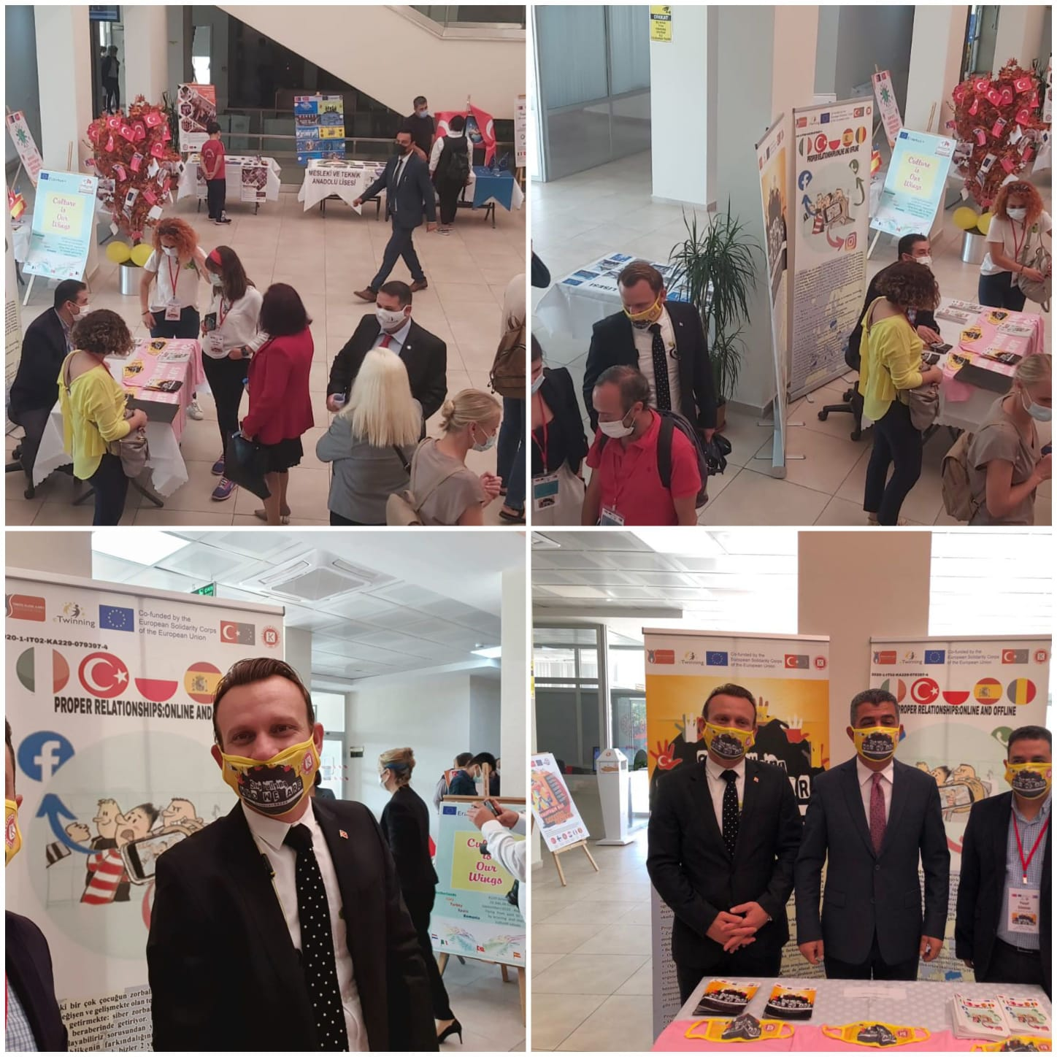
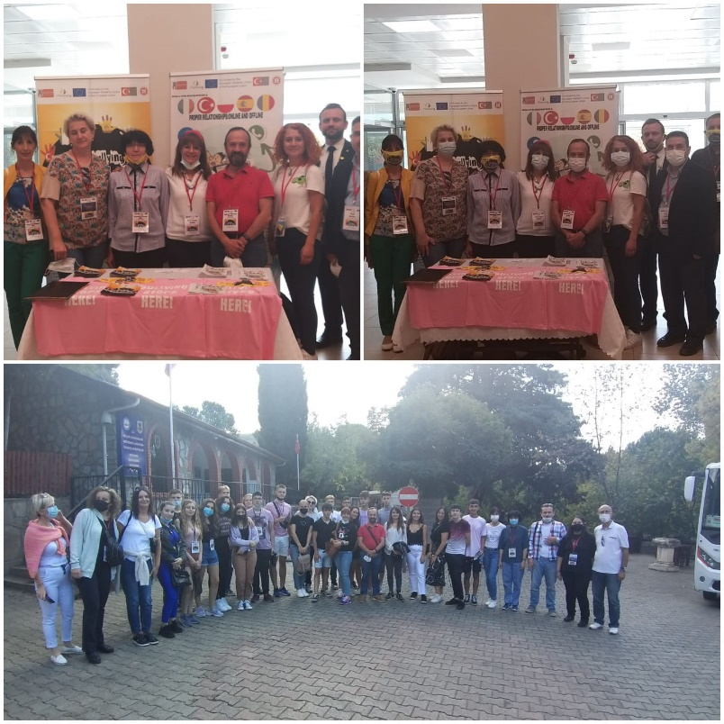

A social experiment on bullying prepared by Nevzat Karalp Anatolian High School. Watch and see the effects.

https://www.youtube.com/watch?v=S5eD71l4iUM

We met with Provine Director of National Education to disseminate our project with partners.
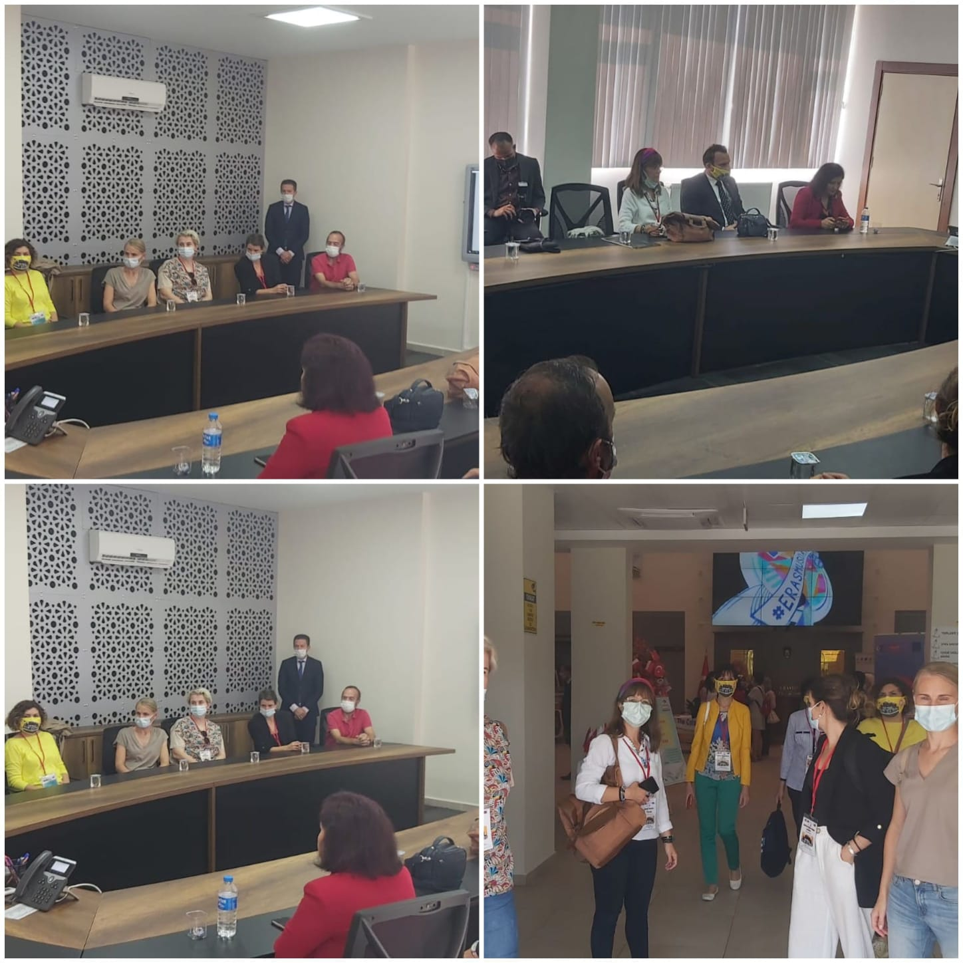
This is our luch break in the school garden
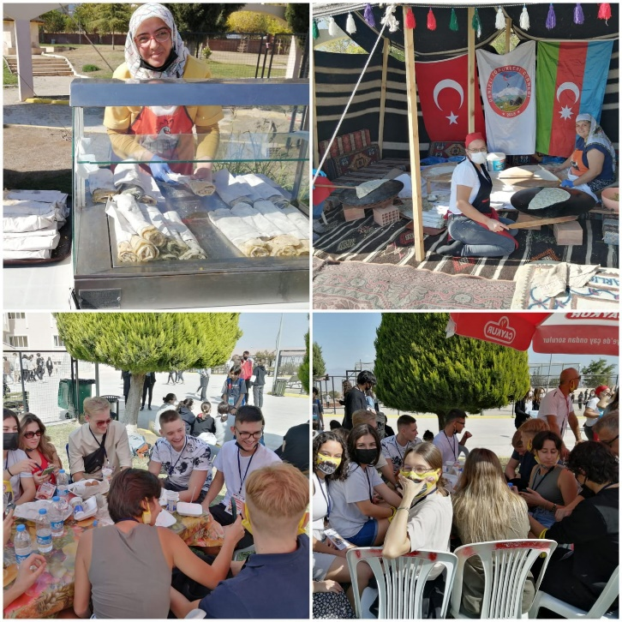
These are our trips and other cultural events
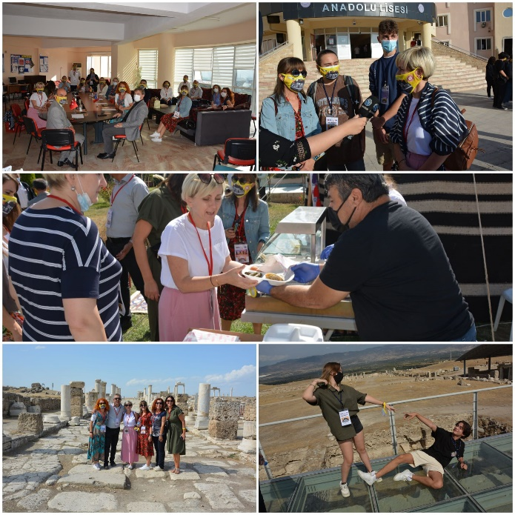
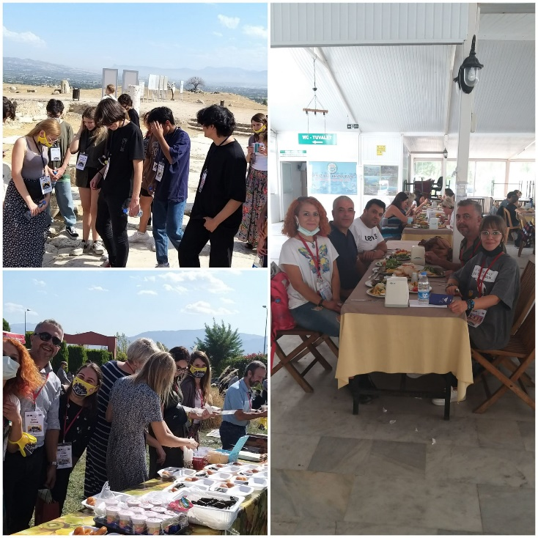
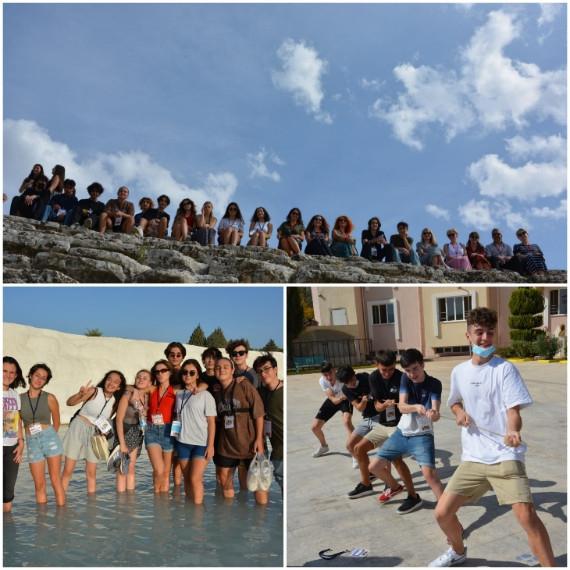
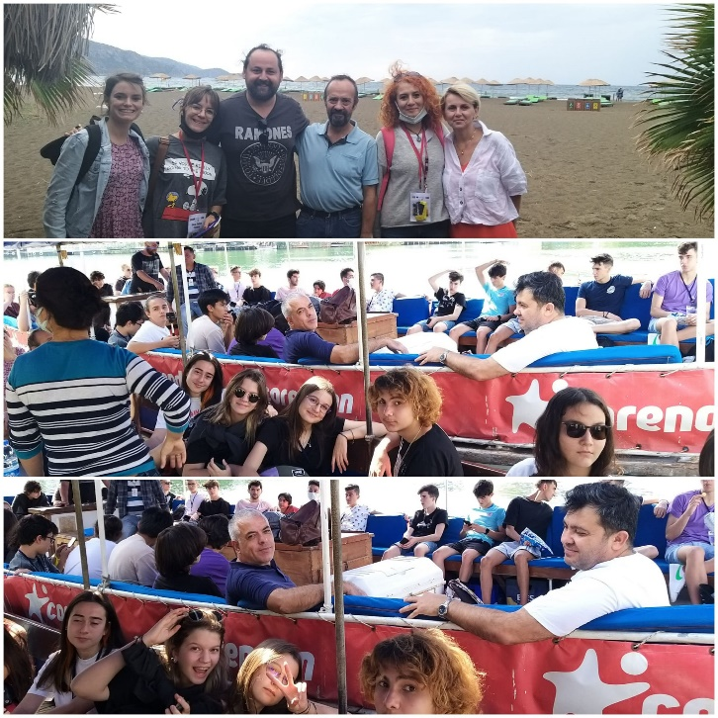
Workshop of glass bineal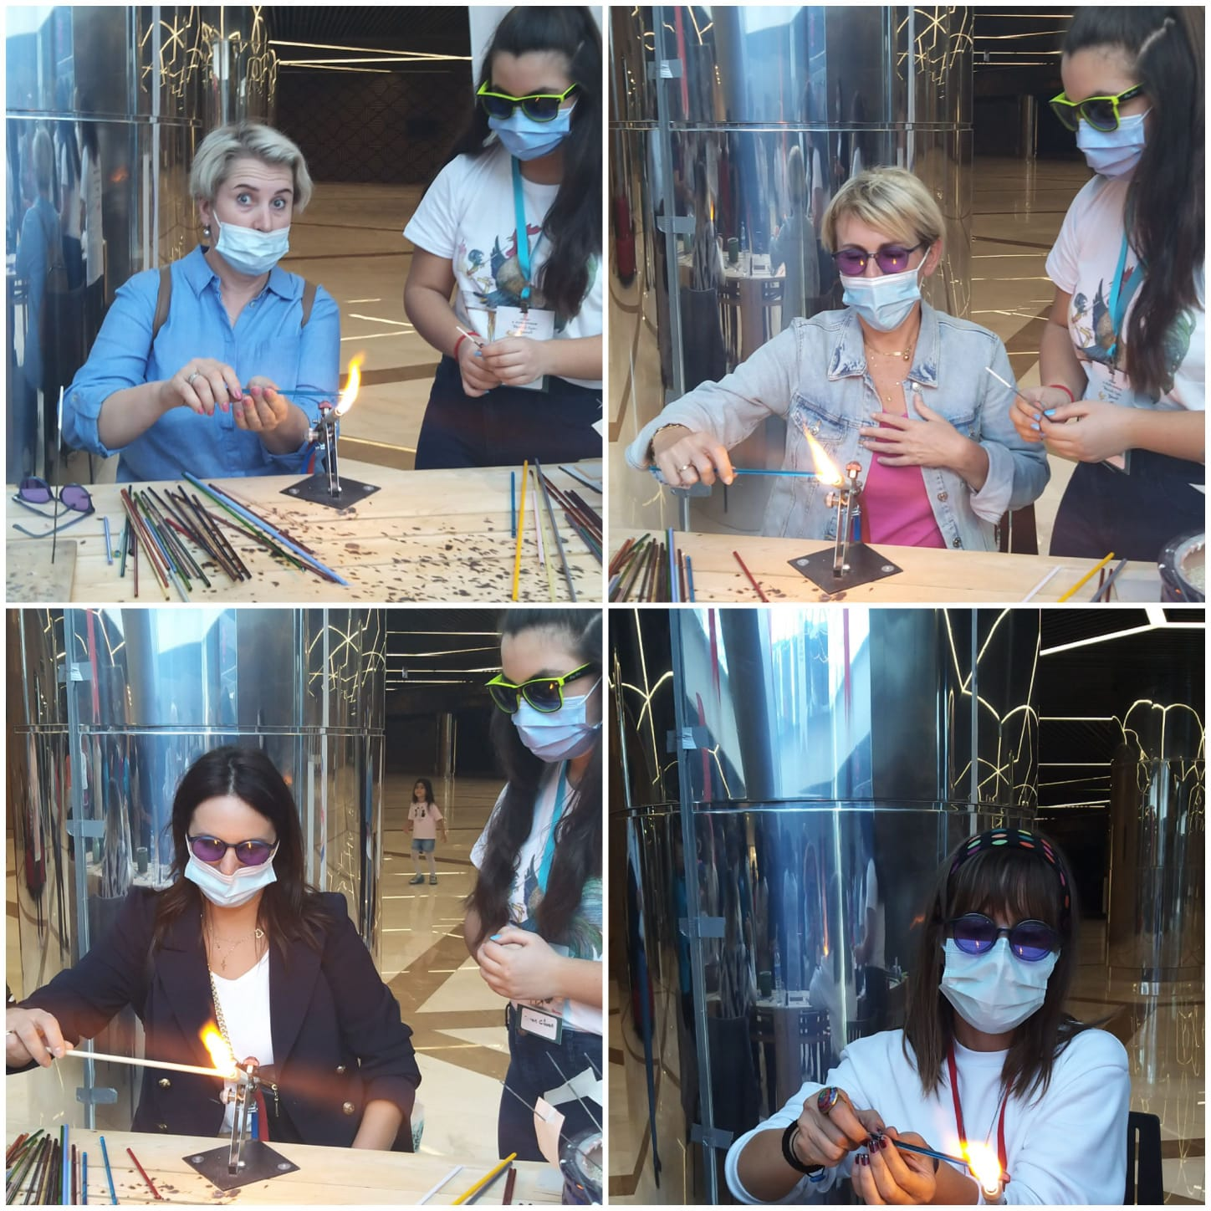
Some visuals of our farewell party
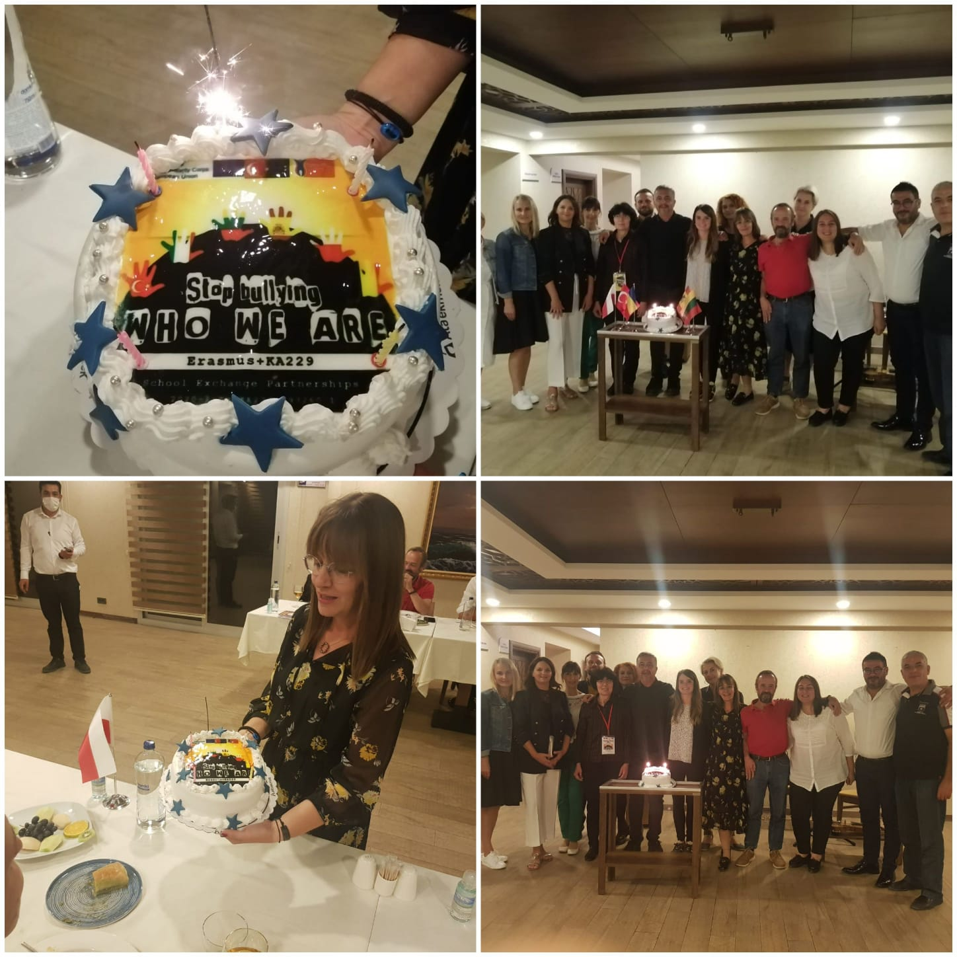

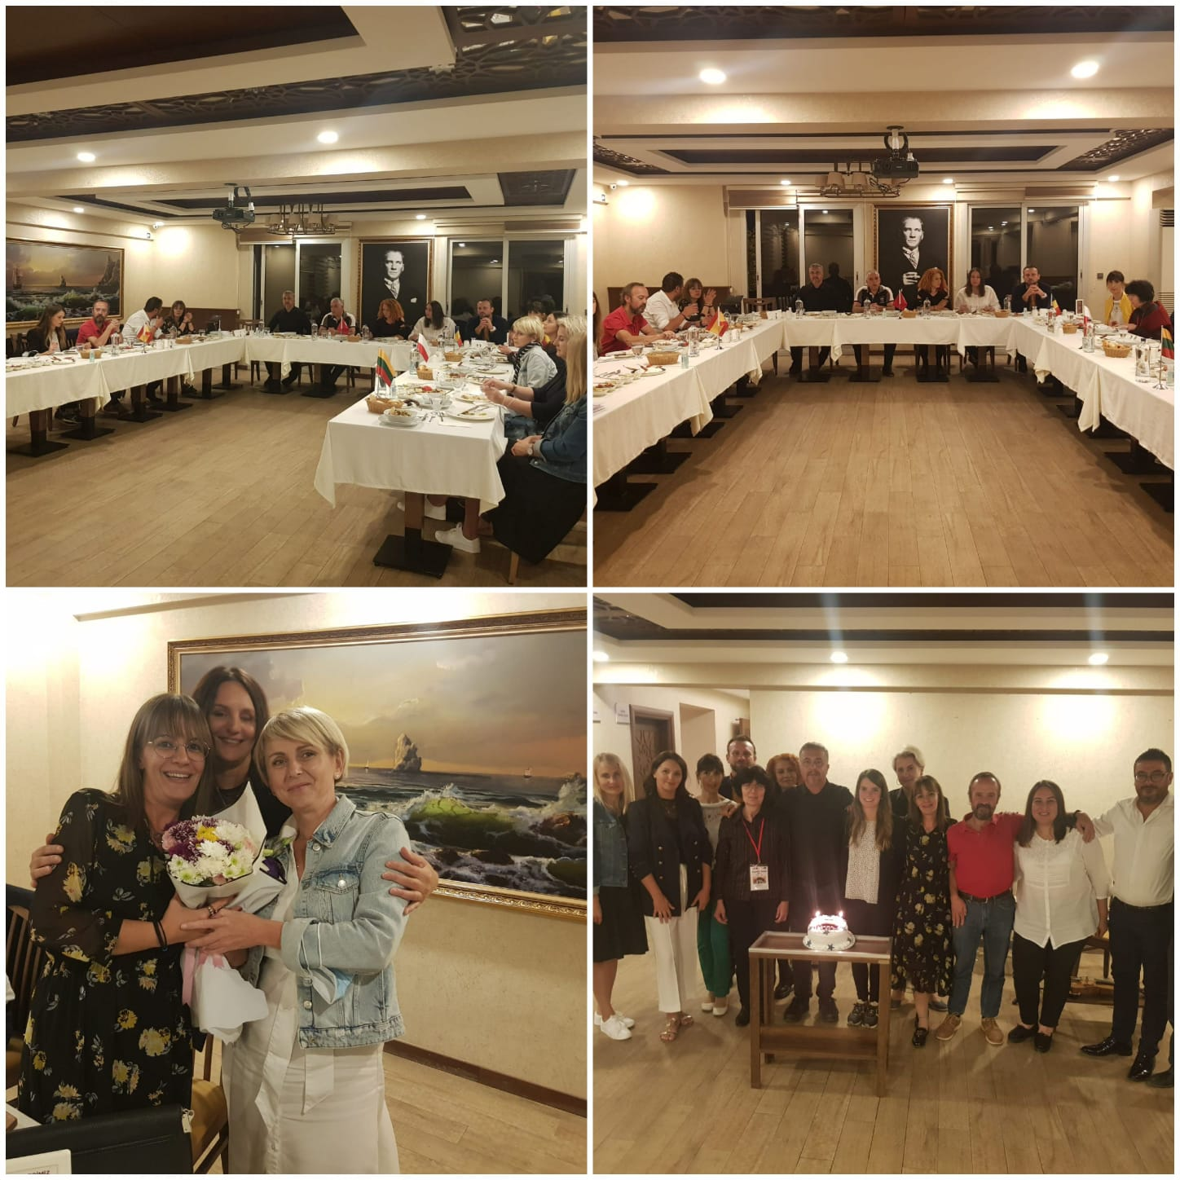
Our first LTT “Social inclusion through traditional games” is on media.
https://www.denizliglobal.com/haberler/kent/nevzat-karalp-anadolu-lisesi-avrupali-misafirlerini-agirladi/20112/

https://www.denizlikenthaber.com/nevzat-karalp-anadolu-lisesi-avrupali-misafirlerini-agirladi/25363/
https://www.sporcu20.com/nevzat-karalp-anadolu-lisesi-avrupali-misafirlerini-agirladi/9550/

https://hizmetgazetesi.com.tr/?p=85700

https://zsbio.lbl.pl/
http://bilgoraj.com.pl/erazmus-w-zsbio,,3,11,11,1,28117,n.html

NOVEMBER 2021
ODD SOCKS DAY PHOTOS
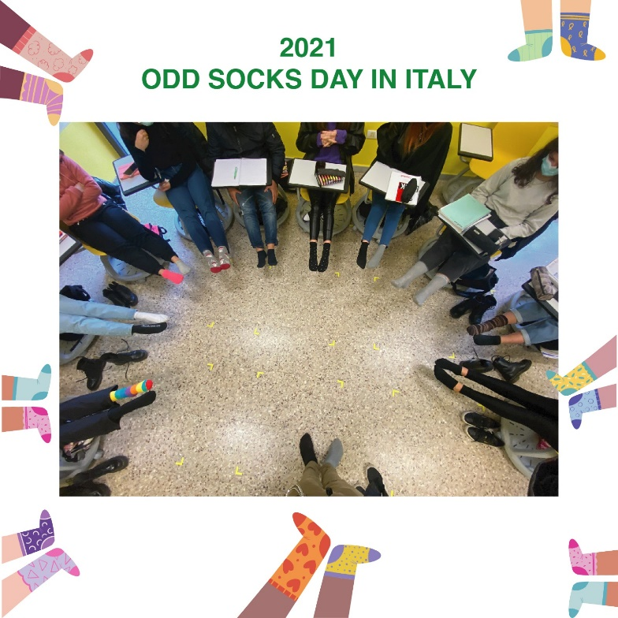
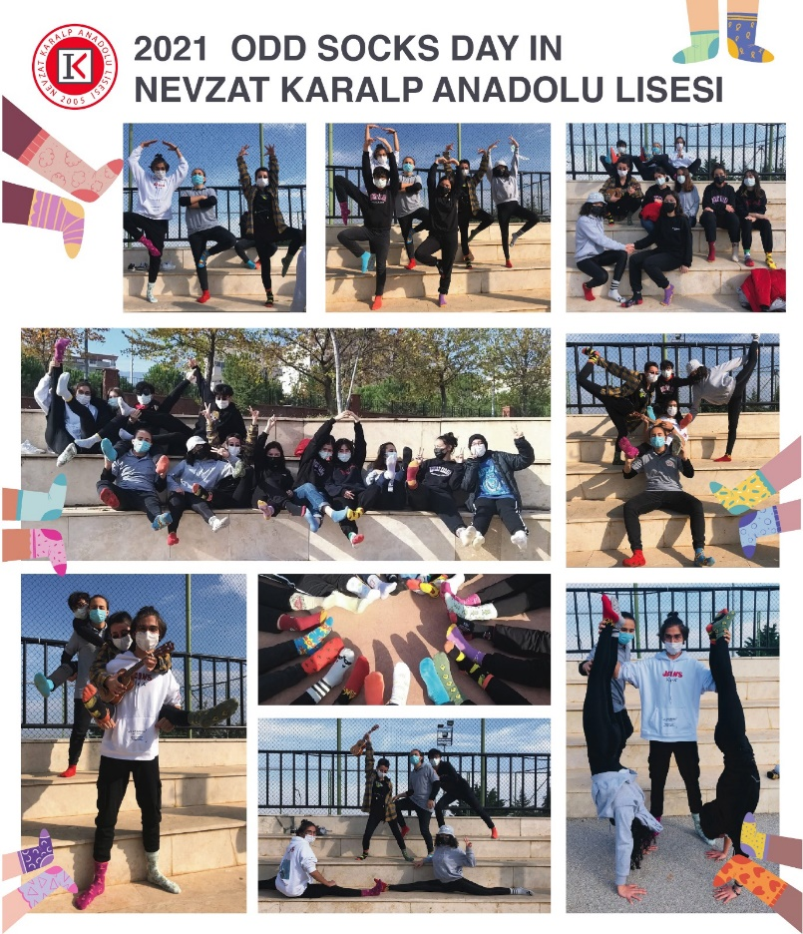
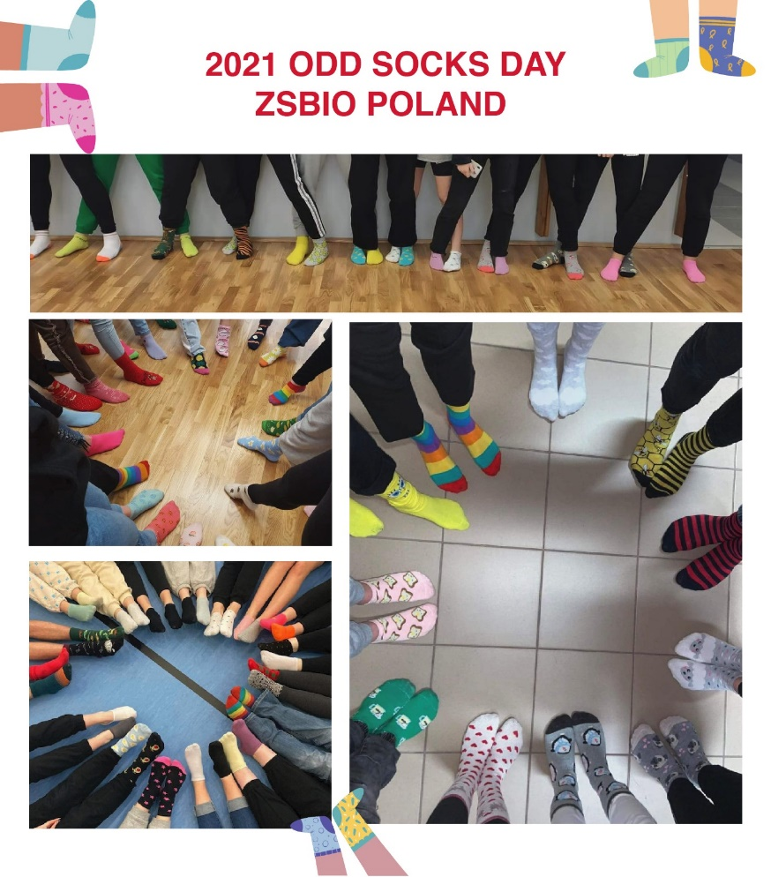
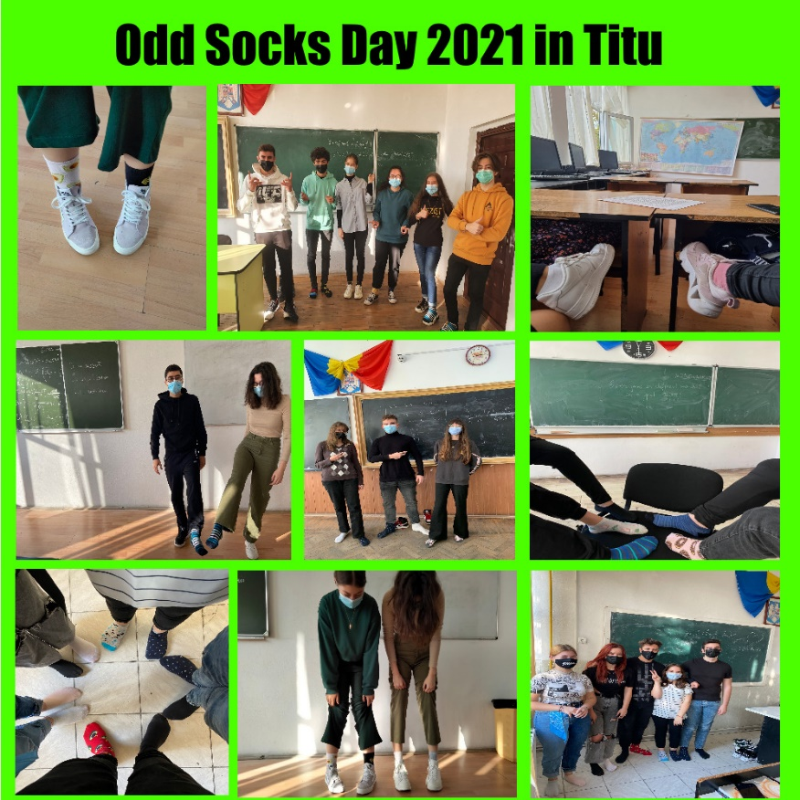

CHANGE BEGINS WITH US PHOTOS
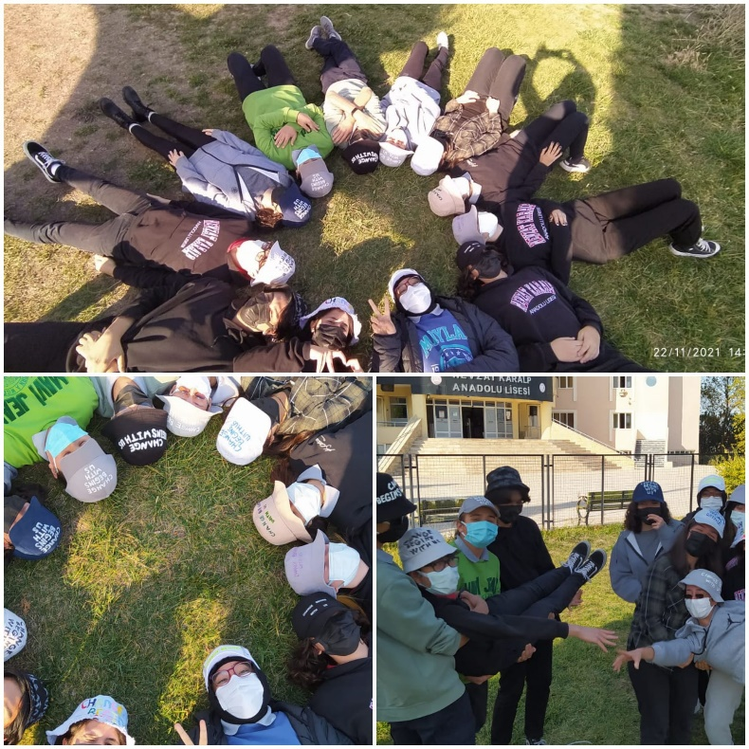

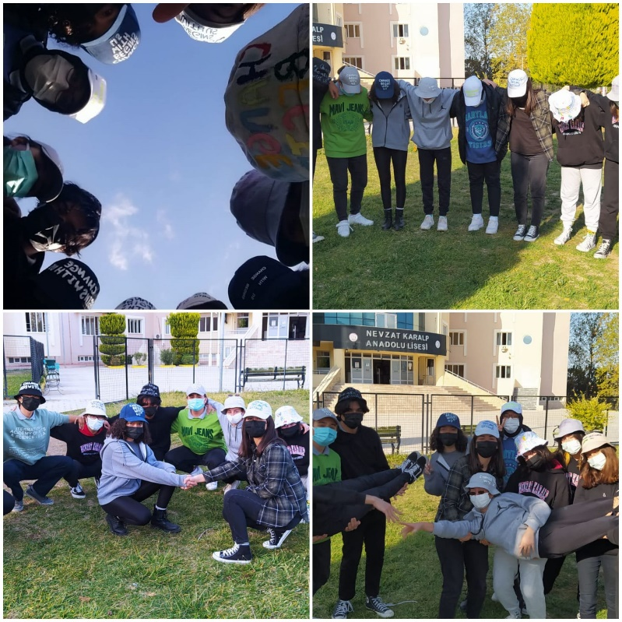

For Anti-Bullying Week NKAL Students Made a Video to Awake People

https://youtu.be/b_SrCHYa-2I

Spanish School’s video on bullying
https://youtu.be/IPLUfaR8HwY

DECEMBER 2021
This is the magazine of our traditional New Year celebration in Turkey
https://prezi.com/view/7gl0rJO1WFgCp3MdRGIu
How Turkish people celebrate New Year
https://youtu.be/fCEX88bkmm0
Celebrations from each partner school
https://padlet.com/simoneta/9ellcoyd2859944r

